

**Version 0.9**

**User’s Guide**

**CS3215 Team9: 0110**

**Gu Yang**

**Li Yi**

**Li Zichen**

**Lu WenHao**

**Tso Shuk Yi**

**Yu Qiqi**

Table of Contents

1. About CLEANSync 2

2. CLEANSync guide 3

2.1Installation CLEANSync 3

2.2Starting CLEANSync 3

2.3 Creating a new CLEANSync Job 3

2.4 Accepting a CLEANSync Job 4

2.5 Synchronizing a job 5

2.6 Conflicts 8

2.7 Deleting a job 9

3. About Us 10

# About CLEANSync

Frequently need to work on the same files and folders on 2 different computers? Having trouble ensuring both sets of files and folders are updated? Let CLEANSync handle that for you!

CLEANSync is a one stop user-friendly and file synchronization software that facilitates the daily back-up and synchronization needs of Users who have to bring home the files from the office to continue their work at home and thus have to ensure that the two sets of files at both locations are synchronized. Other than conventional synchronization between 2 folders, CLEANSync utilizes our new technology, Clean Synchronization that allows users to sync two computers using a third USB device, while keeping disk space usage on the external device, to a minimum. With Clean Synchronization, users can synchronize between workstations using an external device without keeping track of two separate synchronization jobs of the external drive to each of the computers separately.

# CLEANSync guide

## 2.1Installation CLEANSync

Unzip CLEANSync_v0.9.zip to any directory in your computer. A folder “CLEANSync v0.9” will be created in that directory.

## 2.2Starting CLEANSync

To start, click on CleanSync.exe located inside the CLEANSync v0.9 folder.

2.3 Creating a new CLEANSync Job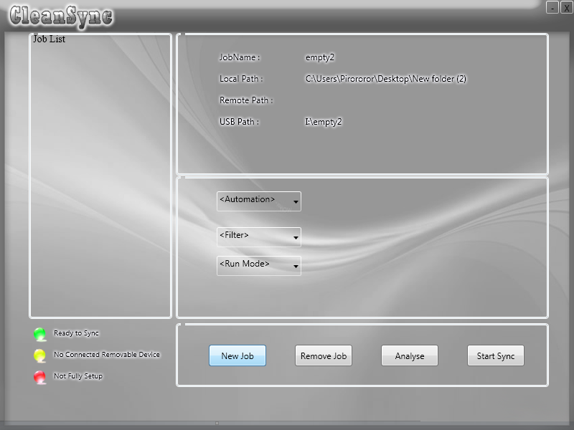

* From the main screen, click on "new job" to create a new job.

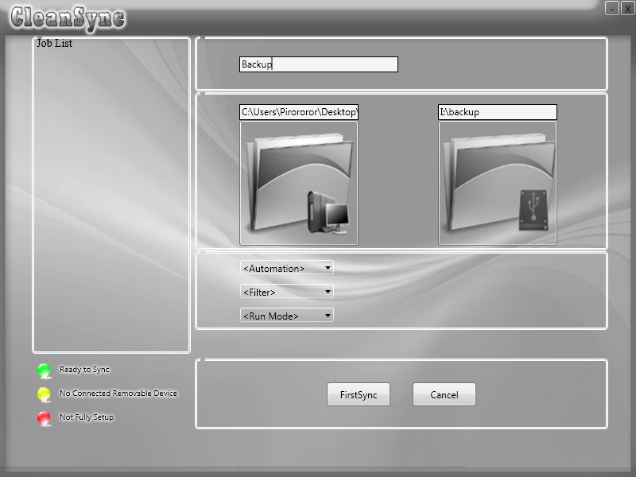

* Enter a name for the job, and select the folder to synchronize.
* Select a folder on the USB drive to store the data on the USB drive.
* You are ready to do a first time synchronization!
* Click on "FirstSync" to copy all the files from the PC folder to the USB folder.
* Creating a job on this PC is now complete!
* Now you can plug the USB into another computer for the other computer to accept the CLEANSync job.

* Version 0.9: Please select an empty folder on the USB drive.

2.4 Accepting a CLEANSync Job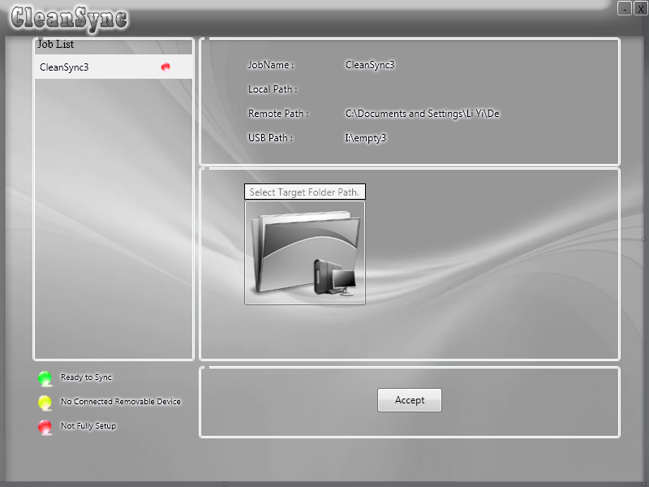

* From the main screen, if a USB drive with a job that has not been accepted is plugged in, it will be shown on the main menu and you will have the option of accepting the CLEANSync job.
* An incomplete job will be listed with the colour red.
* To accept, select the incomplete job, select a folder to synchronize on and click on “Accept”.
* Accepting a CLEANSync job is now complete!

2.5 Synchronizing a job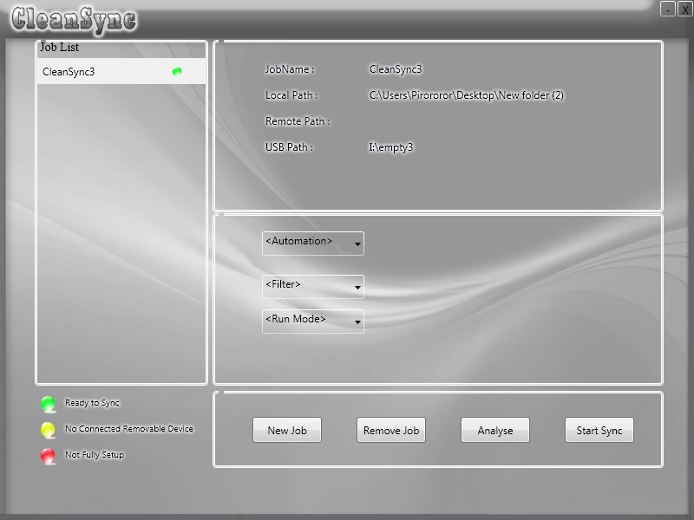

* From the main screen, select the job you want to synchronize.
* Only jobs with their USB drives plugged in are allowed to be synchronized (i.e jobs listed with the colour green).
* Click on Analyse to view the impending changes
*  denotes a new file/folder to be copied over
*  denotes a modified file or a folder whose contents have been changed.
*  denotes a deleted file or folder.

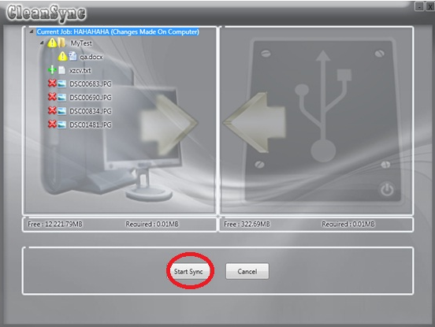

After viewing the changes that will happen from USB to PC and from PC to USB, click on “Start Sync” to start synchronization.

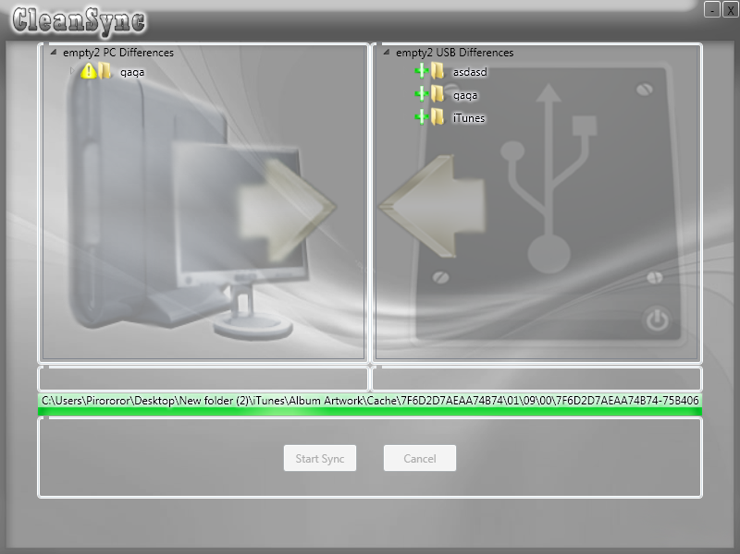

## 2.6 Conflicts

During analyzing, in the event of conflicts, i.e files to be copied from USB to PC has already been modified on the PC, a conflict window will appear:

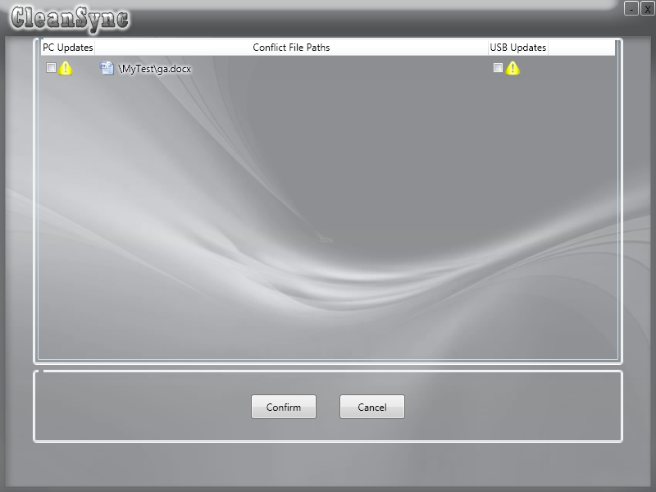

Check on either the “PC Update” box to use the PC’s file as the latest file, or the “USB Update” box to keep the USB’s latest file. Not checking on either of the box will result in neither file being synchronized over.

Note: In version 0.9, checking both boxes causes the USB update to be copied over to the PC but not vice versa.

## 2.7 Deleting a job

To delete a job, select the job you want to delete and click on “Remove Job”.



If the USB device is not plugged in, the data on the USB device will be deleted the next time the USB device is plugged in. To delete the job on the other computer, just plug in the USB into the other computer.

# About Us

0110 is a group of 6 students from the National University of Singapore, studying in the school of computing. CLEANSync is our product for our module CS3215 and has come to be our proud and joy.

Group Leader: Li Yi

Group Members: Gu Yang

Li ZiChen

Lu Wenhao

Tso Shuk Yi

Yu Qiqi

Special thanks to Mr Damith, our course coordinator and mentor for this project, Uncle Soo for his invaluable advice about CLEANSync’s architecture and the other teams in our CS2315 module for giving us invaluable feedback on our product.